Chapter 8, Problem 37.

For the network in Fig. 8.85, solve for i(t) for t > 0.

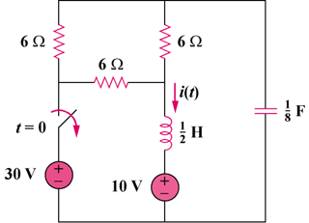

15 V

45 V

Figure 8.85
For Prob. 8.37.

